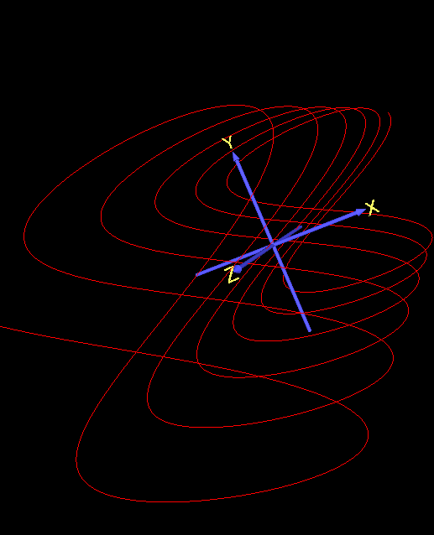

Lab 2 Report

Parametric Curves

SSR3

Yuhan Zhang | CZ2003 Computer Graphics and Visualization | 14 October 2019

Parametric Curves: Changing Resolution

|  |  |  |
| --- | --- | --- |
| **Curve 1a** | **Curve 1b** | **Notes** |
| Above illustrates the parametric curve defined by x=2*pi*u, y=sin(2*pi*u), z=0, with the domain of u being [0,1]. The resolution is set to [100]. It can be found in the file ‘p_sine.wrl’. | Above illustrates a parametric curve with the same equation as Curve 1a, but the resolution is change from [100] to [5]. | In vrml, a parametric curve is created by sampling points along the equation of the curve and connecting the points with straight lines. Therefore, the more samples used, the smoother the curve will appear because the distance between the sampled points are shorter. This can be observed when comparing Curve 1a and Curve 1b. |
| **Curve 2a** | **Curve 2b** | **Notes** |
| Above illustrates the parametric curve defined by x=u, y=u, z=0, with domain of u being [0,1]. The resolution is set to [100]. It can be found in the file ‘p_line.wrl’. | Above illustrates a parametric curve with the same equation as Curve 2a, but the resolution is changed from [100] to [1]. | Since the curve x=u, y=u, z=u defines a straight line, a reduction in the resolution of the curve does not change its appearance. This is because only 1 sample is necessary to depict a straight line. |
| **Curve 3a** | **Curve 3b** | **Notes** |
| Above illustrates the parametric curve defined by x=cos(2*pi*u), y=sin(2*pi*u), z=0, with domain of u being [0,1]. The resolution is set to [100]. It can be found in the file ‘p_circle.wrl’. | Above illustrates a parametric curve with the same equation as Curve 3a, but the resolution is changed from [100] to [5]. | Please refer to the note for Curve 1. Similarly, a parametric circle would better resemble a circle instead of a polygon when the resolution is higher. This can be observed in Curve 3a and 3b. |
| **Curve 4a** | **Curve 4b** | **Notes** |
| Above illustrates the parametric curve defined by x=2*cos(2*pi*u), y=sin(2*pi*u), z=0, with domain of u being [0,1]. The resolution is set to [100]. It can be found in the file ‘p_ellipsoid.wrl’. | Above illustrates a parametric curve with the same equation as Curve 4a, but the resolution is changed from [100] to [10]. | Please refer to the notes for Curve 1 and 3. |
| **Arc 1a** | **Arc 1b** | **Notes** |
| Above illustrates an arc of the circle represented in Curve 3a. It is defined by x=sin(pi*u/2), y=cos(pi*u/2), z=0, with domain of u being [0,1]. The resolution is set to [100]. It can be found in the file ‘p_circle – Arc.wrl’. | Above illustrates a parametric curve with the same equation as Arc 1a, but the resolution is changed from [100] to [3]. | Changes in resolution for arcs and different sections of a curve is affected in the same fashion as the curves analyzed previously. Please refer to notes for curve 1 and 3. |
| **Arc 2a** | **Arc 2b** | **Notes** |
| Above illustrates an arc of the ellipsoid represented in Curve 4a. It is defined by x=2*cos(pi*u/2), y=sin(pi*u/2), z=0, with domain of u being [0,1]. The resolution is set to [100]. It can be found in the file ‘p_ellipsoid - Arc.wrl’. | Above illustrates a parametric curve with the same equation as Arc 2b, but the resolution is changed from [100] to [2]. | Please refer to notes for Arc 1. It is evident from Arc 2a and 2b that a higher resolution can better represent an arc. |
| **Curve 5a** | **Curve 5b** | **Notes** |
| Above illustrates a parametric curve defined by x=u*sin(4*pi*u), y=u*cos(4*pi*u), z=0, with domain of u being [0,1]. The resolution is set to [100]. It can be found in the file ‘p_spiral.wrl’. | Above illustrates a parametric curve with the same equation as Curve 5a, but the resolution is changed from [100] to [16]. | For each resolution, the number of samples taken per revolution on the spiral is the same and not dependent on the length of each arc. This means that the spiral will appear less resolved in its outer revolutions as compared to its inner revolutions since the distance between each sample is shorter for inner revolutions. This can be observed in Curve 5b. Similarly, if the resolution is set to the same value as the spiral’s rotation multiplier, the result would appear as if the spiral is a straight line. |
| **Curve 6a** | **Curve 6b** | **Notes** |
| Above illustrates a parametric curve defined by x=1.2*sin(8*pi*u), y=1.2*cos(8*pi*u), z=2*u, with domain of u being [0,1]. The resolution is set to [200]. It can be found in the file ‘p_helix.wrl’. | Above illustrates a parametric curve with the same equation as Curve 5a, but the resolution is changed from [200] to [10]. | Please refer to notes for Curve 5. Given a resolution, the distance between each sample is constant as long as each revolution in the helix has the same length. This can be observed in Curve 6b. |

Parametric Curves: Changing Parameter

|  |  |  |
| --- | --- | --- |
| **Curve 7a** | **Curve 7b** | **Notes** |
| Above illustrates the same curve as Curve 6a. The domain of u is set to [0,1] and the resolution is set to [200]. It can be found in the file ‘p_helix.wrl’. | Above illustrates a parametric curve with the same equation as Curve 6a and 7a, but the domain of u is set to [-2,2]. The resolution stayed the same at [200]. It can be found in the file ‘p_helix – Extended.wrl’. | As the domain increases, the number of spirals in the helix and the length of the helix also increases. This can be observed by the change from Curve 7a to Curve 7b. However, without a corresponding change in resolution, the curve would appear less smooth since the distance between the sampled points are larger. |
| **Curve 7c** | | **Notes** |
| Above illustrates a parametric curve with the same equation as Curve 7b, but the resolution is changed from [200] to [800]. | | Since the domain of Curve 7b is 4 times larger than that of Curve 7a, a corresponding change in resolution would be to also increase the resolution so it is 4 times that of Curve 7a. This is shown in Curve 7c. |